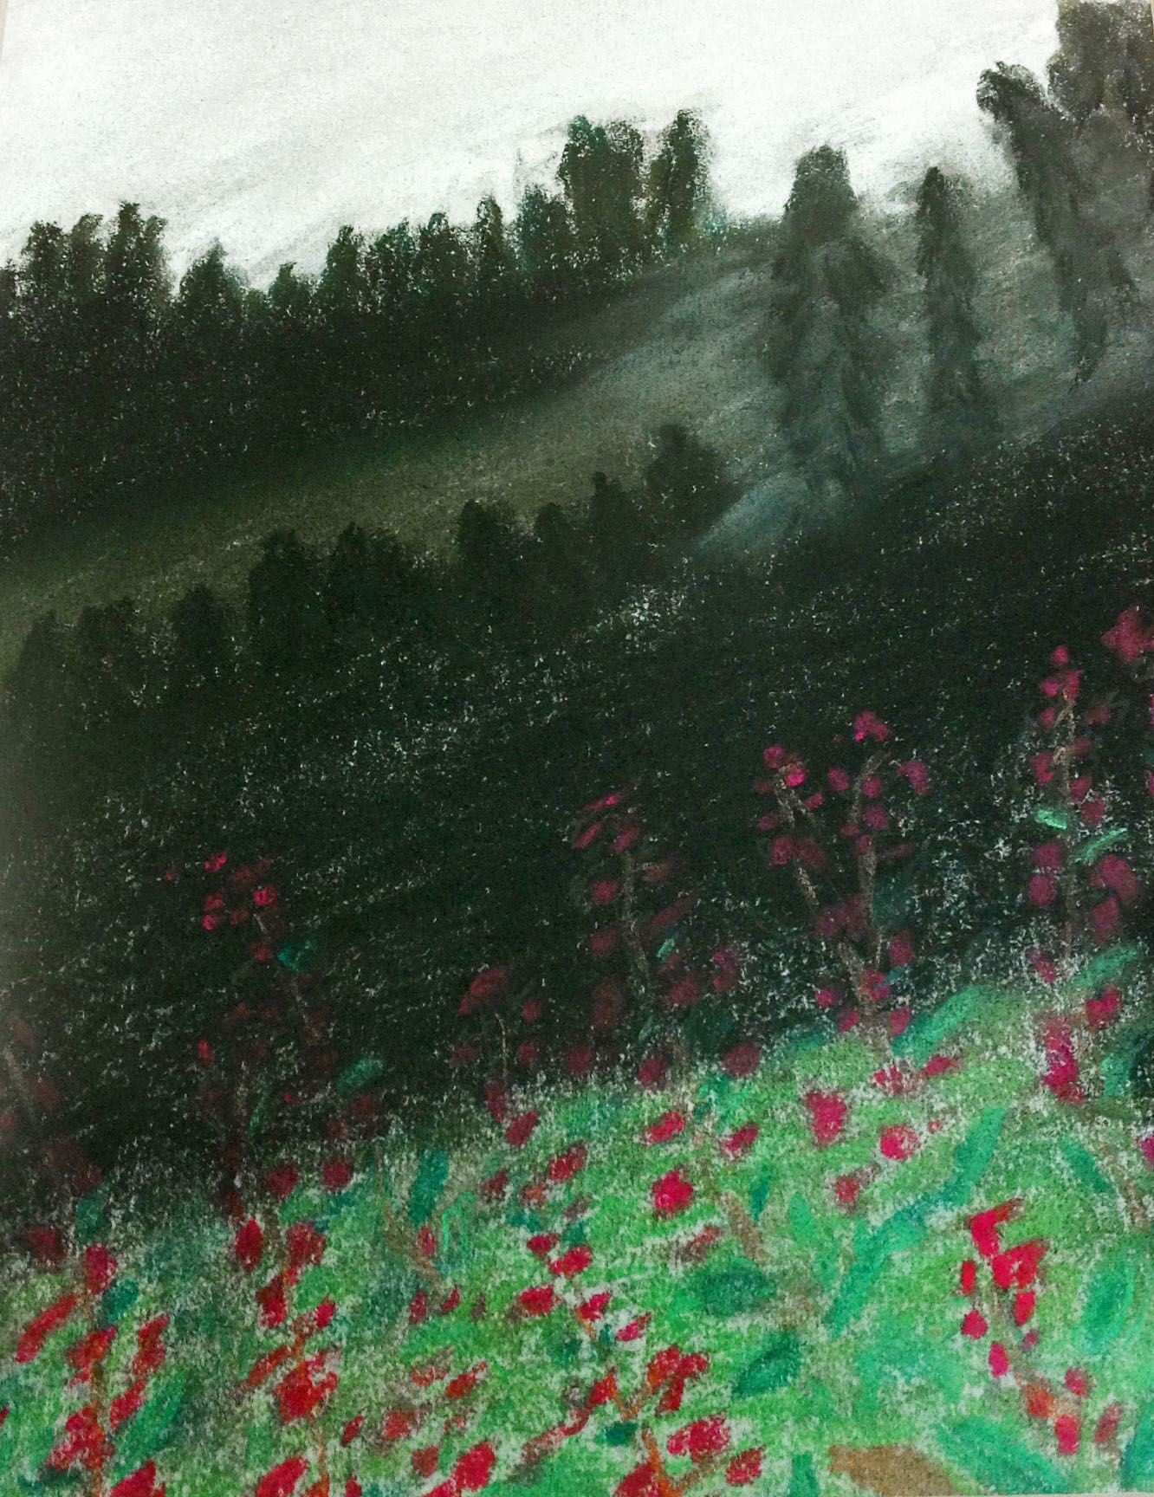

Free Dinner **to the first 200 people, May 18’th @ 5:00pm**

**First 10 drums to sign up via**

[**NativeAmericanStudentAssociation@OregonState.edu**](mailto:NativeAmericanStudentAssociation@OregonState.edu)

**B by May 1st, 2013 get paid $50 a session. Drums who don’t re register split blanket dance money**

**For special accommodations or vendor information contact T Tyler Hogan or Elese Washines at elese.washines@gmail.com**

**Sponsored by SEAC and Educational Activities**



Native American Student Association’s 37th Annual

**“Honoring Native Youth”**

**MC:** Gilbert Brown

**AD:** TBA

**Head Man:**

Matthew Clements

**Head Woman:**

Latrishia “Dottie” Scabbyrobe

**Host Drum:**

**North Bear,**

**Wind River Reservation**

**Honor Drum:**

Bulls & Bears ,Portland

**Young Adult Dance Competition (ages 14-24):**

**A Young Men-traditional, grass, fancy.**

**Young Women – traditional, jingle, fancy**

**S Specials:**

**“Daddy’s Girl” Special**

**(F (Father/Daughter, Grandpa/Grandaughter social dance)**

**Young Women – traditional, jingle, fancy**